
Company
Logotype

Cone Beam Computed Tomography- Report



Porur Dental X-rays & CBCT

Patient Name : Mr. Prashant | Date of Report : 29.06.2024
Age/ Gender : 46 years/ Male | Region of Interest : CBCT Full Skull
Referring doctor: Dr. Siva Subramanian | Indication : Implant assessment
Clinical Notes: Nil
PATIENT INFORMATION

CBCT- Full Skull provided
CBCT – IMAGE DETAILS

RADIOGRAPHIC INTERPRETATION

- Completely missing crown and root portion in relation to 18, 26, 28, 36, 37, 38, 46, 48.
- Root stumps: 15
- The alveolar ridge in relation to the maxillary and mandibular alveolar ridge are present with normal trabecular pattern.
- Hyperdense crown structure is evident in relation to 14.
- Presence of hyperdense screw like structure in relation to 12 is evident.
- Restored: 24.

IMPLANT ASSESSMENT

 | 15 region | 26 region | 27 region
Sub-Crestal (in mm) | - | - | 14.6
Mid- Crestal (in mm) | - | - | -
Distance between the alveolar ridge and floor of the maxillary sinus (in mm) | 2.1 | 2.4 | 7

 | 36 region | 37 region
Sub-Crestal (in mm) | 8.3 | 6.4
Mid- Crestal (in mm) | 9 | 8.5
Distance between alveolar ridge and the inferior alveolar nerve canal (in mm) | 17.3 | 17.7
Distance between alveolar ridge and the inferior border of mandible (in mm) | 30.2 | 28.3

 | 47 region
Sub-Crestal (in mm) | 10.6
Mid- Crestal (in mm) | 11.2
Distance between alveolar ridge and the inferior alveolar nerve canal (in mm) | 20.1
Distance between alveolar ridge and the inferior border of mandible (in mm) | 32.4

RADIOGRAPHIC IMPRESSION

- Partially edentulous maxillary and mandibular arch.
- Implant in relation to 12.
- Crown: 14
- Root stumps: 15.

Kindly correlate with clinical findings


IMAGES FOR REFERENCE

RECONSTRUCTED PANORAMIC VIEW

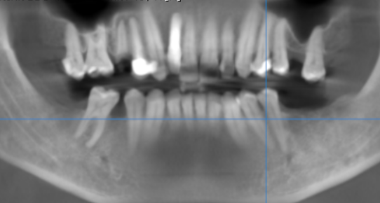

3-DIMENSIONAL VIEW

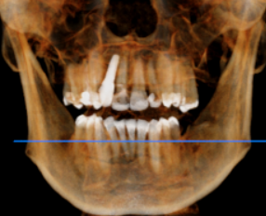

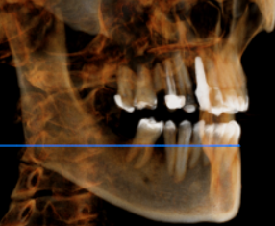
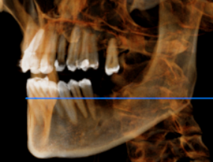

CROSS SECTIONAL VIEW

15 region | 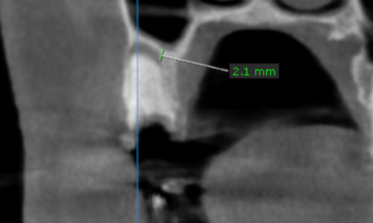
26 region | 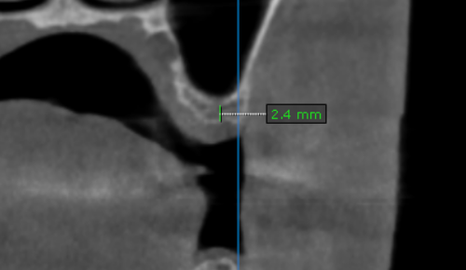
27 region | 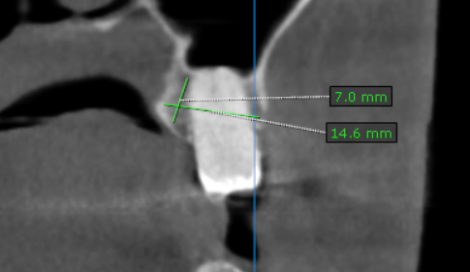
36 region | 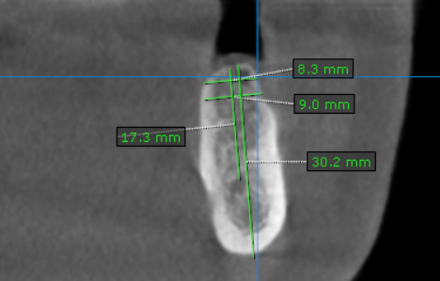
37 region | 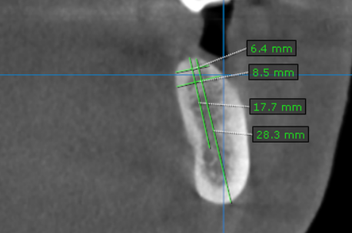
47 region | 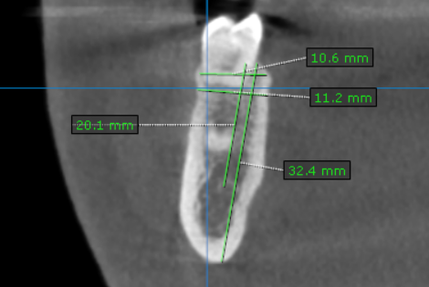

**** End of report ****

